The utility is designed to pick sample locations within a pre-defined filter grid and make the data input and management easy for the user. The utility define allows for squares within the filter grid to be assigned to a zone and weighting for that zone to be adjusted so that the sampling is not purely random. This is a benefit if the assay conditions or equipment do not evenly distribute the particles across the filter medium or if edge exclusion of partial squares is desired. The initial configuration is based on Millipore’s 47mm EZ-pak 0.45um filter, but the source is available for free modification under GNU General Public License v3.0. Any modifications and reproductions of this program are required to follow under the same license.

The coordinate system for the sample grid is based on Excel R1C1 reference style format with the origin at the bottom left of the filter grid. For example, the square in column 8, row 3 (which falls in the Middle zone) would be referred to as ‘R03C08ZM’. Enumeration begins as 1, so there is no row zero or column zero.

The utility has some flexibility integrated into it for ease of future modification, but it still relies on the user for manual configuration. Excel’s “Named Range” feature is used to define where many items are located within the worksheet. The name of a range can be displayed by clicking on that cell and looking in the upper left corner (shown in Fig A). For example, click on R01C01 in the sample grid of the Settings or Main worksheets and the name ‘rngBotLeft’ will be displayed. This is how the utility orients itself and knows where on the worksheet the sample grid is. If rows are inserted above or to the left of this named range the location of the grid changes, but the utility can still locate this cell and operate normally – it isn’t hard-coded to require the grid be in range A1:Q17.

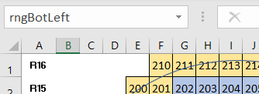

Fig A. If a name is defined for a certain range in Excel, it can be viewed in the upper left corner when that range is selected. If no name is specified, the address of the uppermost left cell in the range is displayed.

The number of squares to sample is specified in the ‘Cells to Sample’ box (another named range: rngCellSamp). Clicking the Random Sample button will take the specified number of squares and break that total down into the grouping proportions defined in the Settings tab. If 10 sample are specified and center weighting is 30%, then the utility will return 3 cells within the Center zone and the remaining 7 cells will be divided in the same manner. If the increments of the weighting are not evenly divisible in the squares requested (ex: 9 squares requested but weighting is specified in increments of 10%, a zone with only 10% weighting would need to sample 0.9 squares), then the utility will assign at least one square to each zone and then reconcile this rounding issue by adding or subtracting squares from the zone with the largest number of squares sampled. If all squares within the grid are to be counted, then the Sample All button will override the value in the ‘Cells to Sample’ box.

After the squares are selected, the utility runs the list through a simple pathing algorithm that starts at the bottom left origin and finds the nearest cell to be called Sample #1 – first on the list. The algorithm then finds the closest cell to Sample #1 to be Sample #2, and so forth until all samples are arranged in a path that reduces unnecessary stage travel during sample counting. This ordered list is then transferred to the Main settings tab as a table for easy data entry and the cells in the grid visual depiction are colored and numbered to match.

Identifying information such as sample location, collection date, etc. are provided and averages for the zones for two items (TWP and Bitumen) are calculated. Clicking the Save button will transfer this information to the Data worksheet in a tabular format with three rows. The first row saves the location of each sample within the sample grid in R01C01Z0 format. The other two rows are the item counts for the two items specified – TWP and Bitumen.

The Clear button will clear the selected squares from the Main worksheet and reset the data collection table. It will not reset the identifying information for the sample (location, name, date, etc.) but this information can be cleared by clicking the Clear Sample Info button.





**Changing the sampling arrangement (Adding/Removing Zones)**

The utility is configured for four zones. If fewer zones are desired, it is optional to delete the named ranges for the obsolete zones, only step 1 is required, If increasing the number of zones, all steps are mandatory.

1. Adjust the constant value for zone count, located in the header of the VBA Sampler module (search: *Const ZONE_COUNT As Long = 4*)
2. Add or remove named ranges in the Settings worksheet for, where XX denotes the number of zones – including a leading zero (“09” instead of “9”):
   1. The zone name (named range format: ‘rngZoneXX’)
   2. The zone weighting (named range format: ‘rngZoneWeightXX’)
3. Add or remove named ranges in the counting summary table in Main worksheet for:
   1. The zone name (named range format: ‘rngLabelZoneXX’)
   2. The number of squares counted in that zone (‘rngTotalSampZoneXX’)
   3. The average count for each item YY (‘rngParItemYYZoneXX’)

**Changing the sampling arrangement (Adding/Removing Items)**

The utility is defined to record two item types by default: TWP & Bitumen. The code refers to these items generically as Item01 and Item02. Updating the number of items is possible, but requires more updates to the underlying VBA code.

1. Add or remove named ranges in the Main worksheet to:
   1. Define the name of the item at the top of the summary table (‘rngLabelItemYY’)
   2. The average count for each zone XX (‘rngParItemYYZoneXX’)
   3. Provide a column for data entry (‘rngItemYY’)

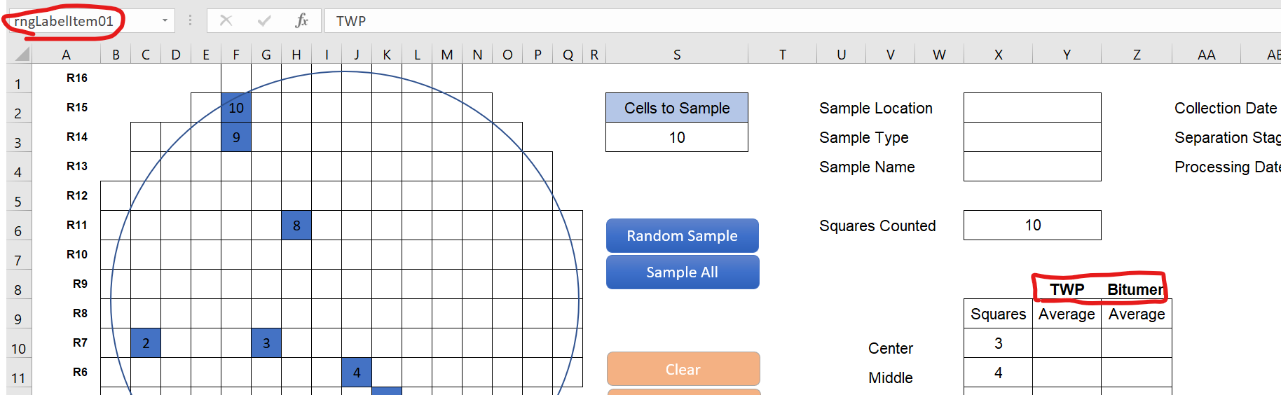

1. Modify the sampleSquares procedure:
   1. Add/remove variable declarations (‘Dim strItem03Address As String’)
   2. Add/remove two calculations for each item (search for: ‘strItem01Address =’ and ‘.Range("rngParItem01Zone”’

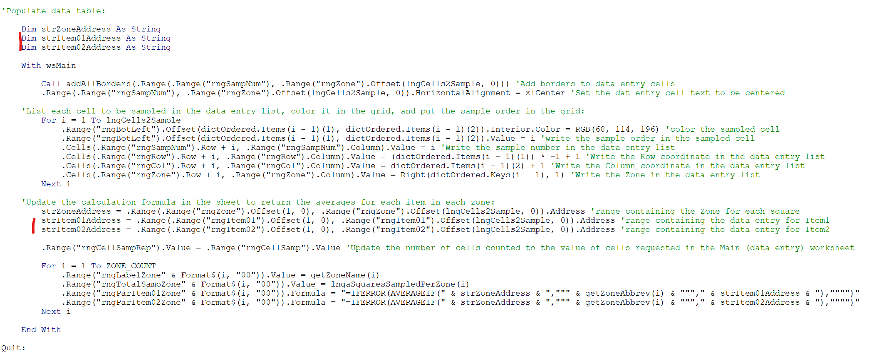

1. Modify the SaveData procedure:
   1. Modify the ‘For Loop’ to run from 1 to (# items + 1) - search: ‘For i = 1 To 3’
   2. Add/remove conditions to the Select Case Statement (search: ‘Case Is = 2’)

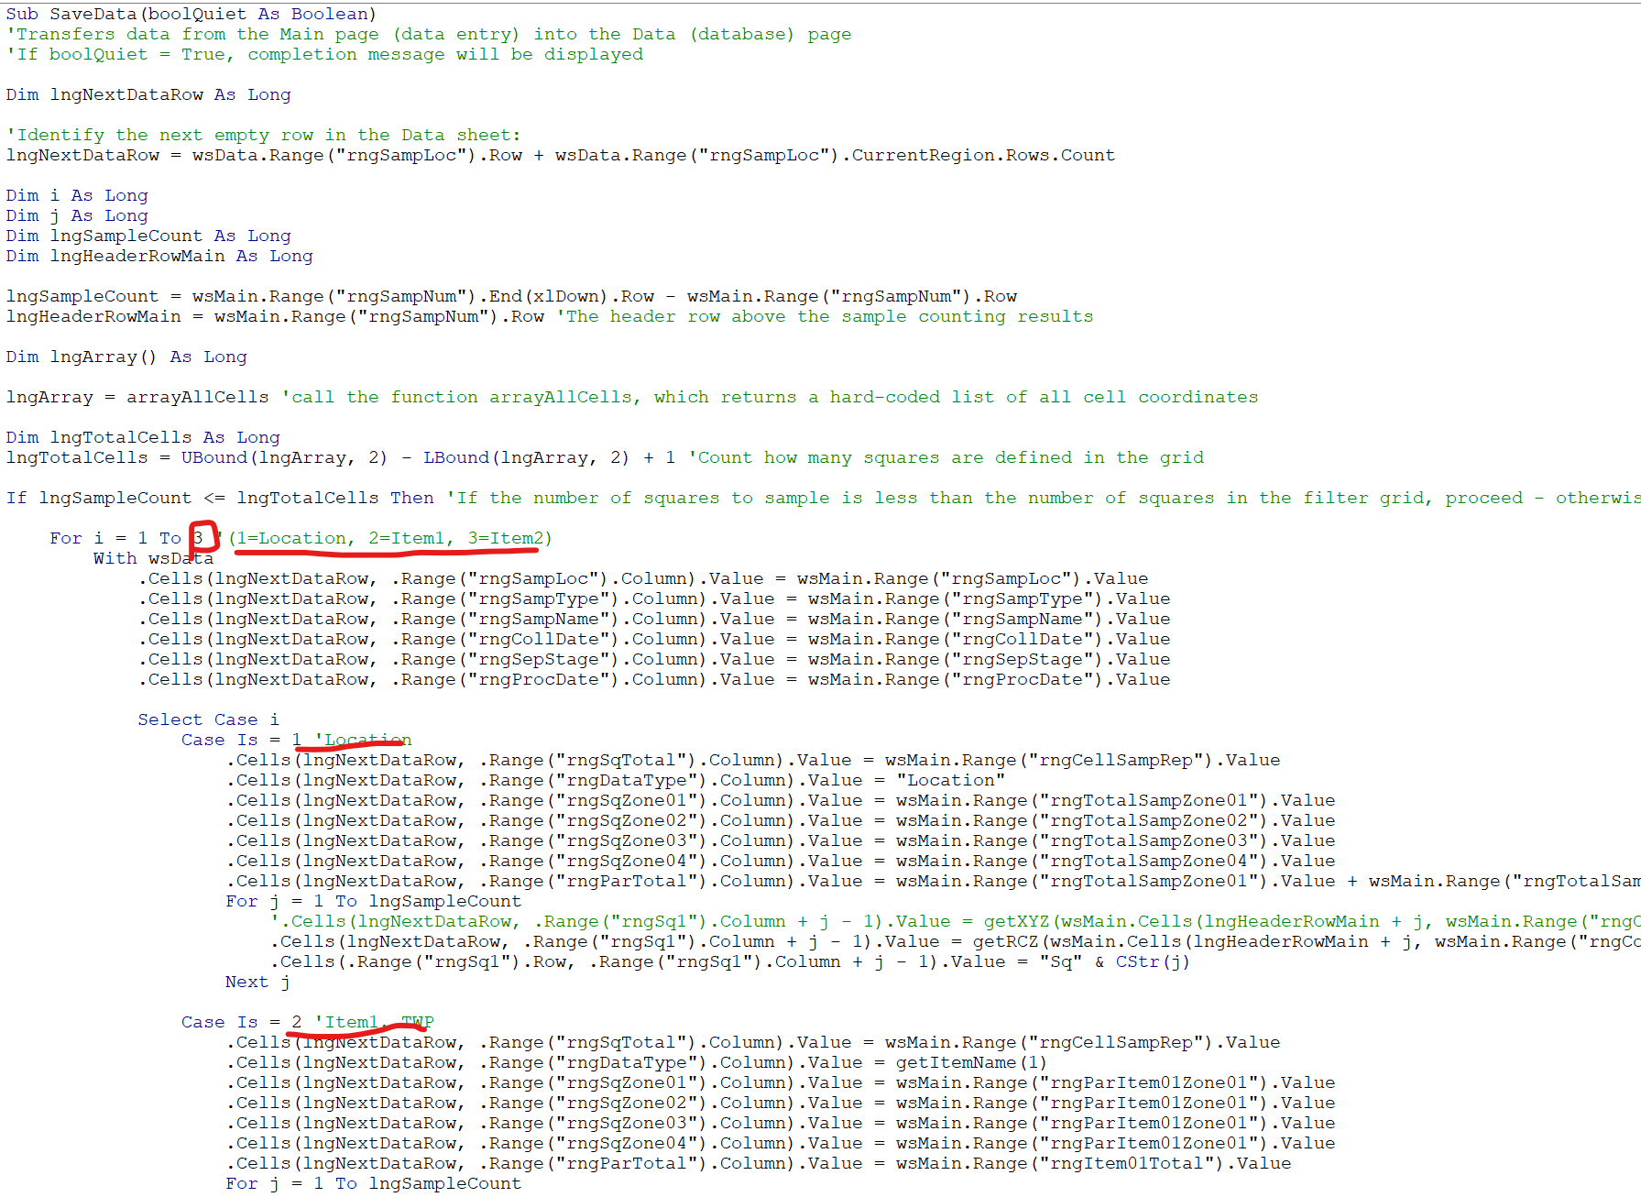

**Changing the filter type**

The utility was defined for use with Millipore’s 47mm EZ-pak 0.45um filter, but it can be adjusted to any number of rows and columns. This modification requires changes to both the Excel worksheets and the VBA code.

1. The named range ‘rngBotLeft’ in both the Main and Settings worksheet is located at the (1,1) position in the grid or the lower left corner. When increasing the size of the sample space, manually insert rows or columns so there is enough space for the grid to fill in without over-writing existing important cells. If increasing the number of rows, make sure rngBotLeft has enough empty rows above it to complete the grid pattern (ex: if 20 rows are desired, rngBotLeft must be in row 20 or greater).   
   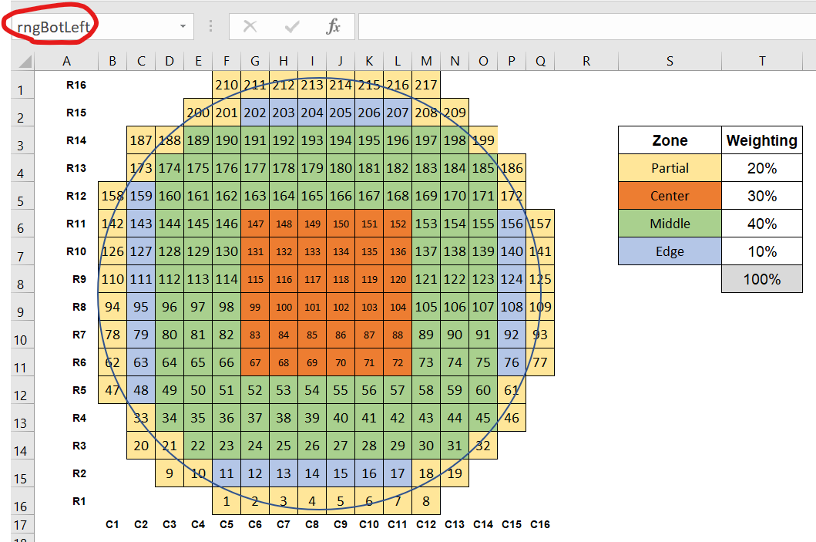
2. Update the number of rows and columns in the new sample grid by updating constants in the header of the Sampler module (search: ‘ROW_COUNT As Long = 16’ and ‘COL_COUNT As Long = 16’).

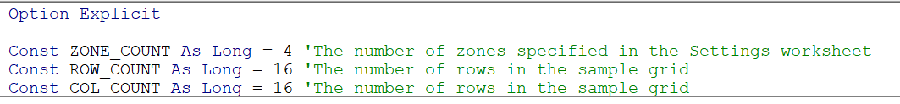

1. Update the VBA procedure ‘arrayAllCells’ to indicate which squares are outside the sampling grid. This procedure starts by assuming all items in a square X rows wide by Y columns tall is in the grid, then removes cells that are not included (which are manually specified).

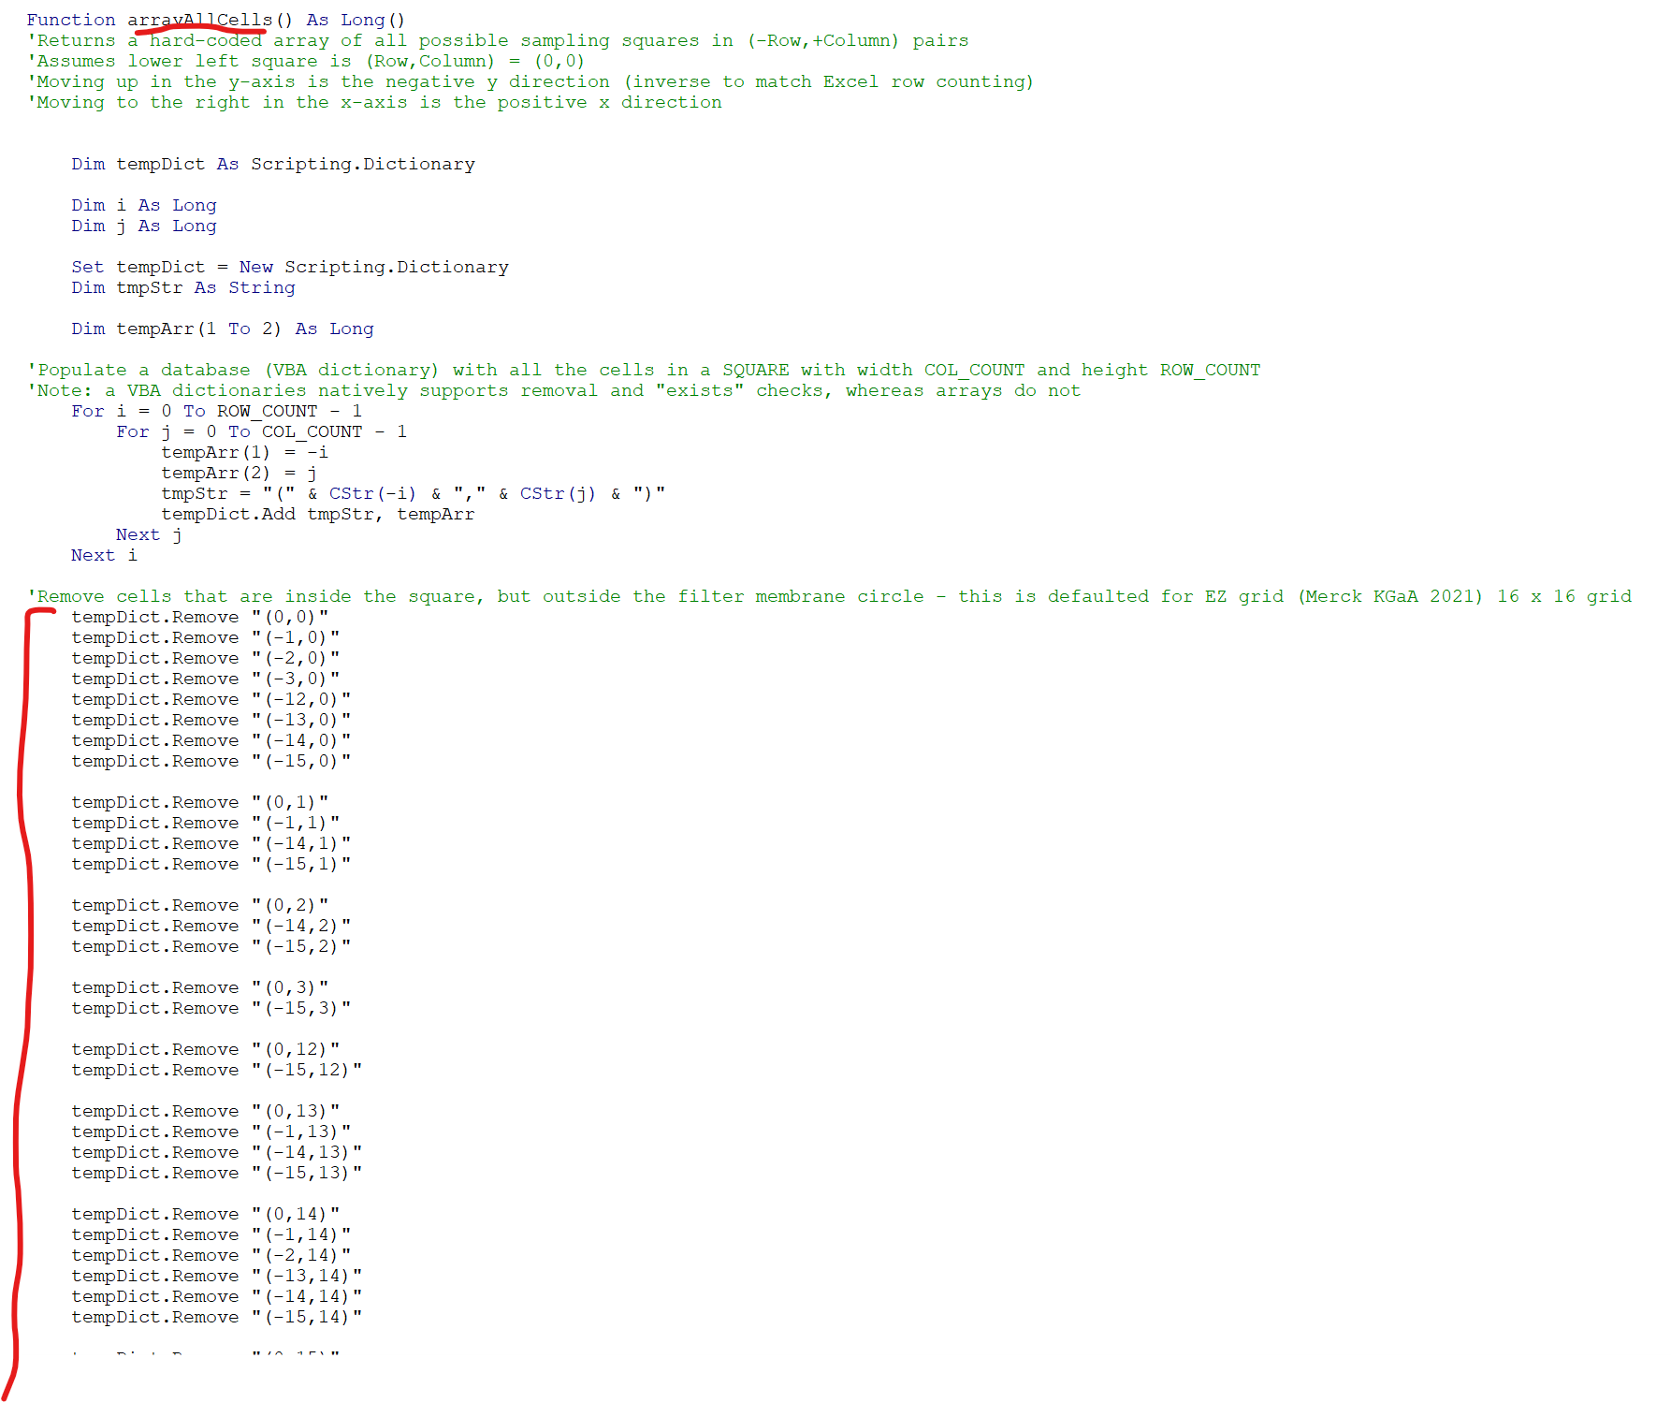

Modifying the information inputs

The Save button uses named ranges to transfer information from the Main worksheet to the Data worksheet. For example, there is a named range called ‘rngSampLoc’ for the Sample Location in the Main worksheet and also in the Data worksheet. If the description of this item needs to be changed to something else, say Sample Serial Number, there is no need to modify the named ranges or VBA code. Simply change the text ‘Sample Location’ to ‘Sample Serial Number’ in the Main and Data worksheets and the data will continue to transfer.

If additional identifiers information fields are desired:

1. Add named ranges to both the Main and the Data worksheets (easier if they’re named the same, but not mandatory)
2. Update the VBA procedure ‘SaveData’ by adding one line to transfer the data between the worksheets (search: ‘.Range("rngSampLoc")’)